Chapter III
Materials and Methods

SECTION – A

3.1 Pearl millet seeds chosen for study
Two pearl millet varieties were procured for the study, one is a Hybrid Bajra variety KMBH-9, procured from the Millet Research Station, Vizianagaram, A.P., India. The second variety is available from local market, which is used as food and feed by the people in and around Visakhapatnam, India.

3.2 Malting studies
Both the seeds varieties were treated separately for the amylase content after malting using the different treatment conditions chosen for study.
3.2.1 Steeping studies
Approximately five gram of the two varieties were weighed and the weights were noted down. These were then exposed to 1% sodium hypochlorite solution for a period of 15 min. The seeds were thoroughly washed under tap water and then using distilled water to remove traces of chlorine adhering the seeds. The seeds were then kept under running tap water 24h. To analyze the changes in the moisture content during the steeping process samples were withdrawn after every 4h and the water droplets adhering the seeds were removed by thoroughly drying them using paper towels and then used for the determination of moisture content and ash content.
3.2.2 Germination
After steeping process the seeds were washed thoroughly and spread as a single layer on a tray covered with filter papers for germination. The two varieties of the seeds were spread separately.
A traditional method used in villages of Andhra Pradesh, India was also tried to compare the growth rate and germination of sprouts for the hybrid variety. In this method, the steeped seeds were tightly packed in a thick cloth and were kept at about one feet depth in the soil. Six bags were placed in the soil and analysis was done at every 24h time interval by taking one bag at a time.
3.2.2.1 Effect of gibberlic acid
Effect of 1ppm gibberlic acid in water on both the varieties was studied. As control, a separate set of steeped seeds was germinated without gibberlic acid treatment. For the germination, the seeds were kept in an incubator at 28ºC and water was sprinkled at regular time intervals to keep the seeds wet. The samples were collected at every 24h time interval and analyzed for changes in the carbohydrate, protein, amylases and proteases content. The changes in the physical characteristics such as moisture content, dry weight and changes in the seed number per gram, weight of desprouted cotyledons and the weight of rootlets and shootlets were monitored. The seed variety yielding the maximum amylases and the optimal day of yield noted down and used as the enzyme source in further studies.
3.3 Kiling
The spourted seedlings were kilned by keeping them in a hot air oven at 45ºC for 18h. The rootlets and shootlets were brushed off carefully and the dry malt is stored for further studies.
3.4 Milling
The pearl millet varieties chosen as the enzyme source as well as the other variety chosen as the substrate were subjected to milling. Care was taken while milling the malt (enzyme source), as increase in temperature leads to denaturation of the enzyme activity.
3.5 Characterization of pearl millet α-amylases
The enzyme derived from the seed sprouts was used for the studying the different parameters, which enhance its performance. The enzyme activity was measured by determining the reducing sugars concentration by DNS method (Kirsop, 1953). The seeds sprouts of the enzyme source were selected and the different parameters, which enhance the performance of the malt α-amylase, were investigated.
The optimal value of one of the parameters was studies first and then incorporated into successive parameter. All the optimal values were determined to achiever the maximum amylase activity.
3.5.1 Effect of molarity of acetate buffer
The enzymes of the malted grains were extracted separately in different molarities of cold acetate buffer ranging from 0.005 to 0.05 by grinding the desprouted seeds of the optimal day. It was then centrifuged and the supernatant was used as the enzyme source.
3.5.2 Effect of pH on the buffer
The optimal pH required for obtaining the maximum α-amylase was selected by varying pH fo the optimal molar buffer solution in the range from 3.0 to 6.5. the malt enzymes were extracted in the buffer solutions. Intial pH of the buffer was adjusted using 0.1N acetic acid and 0.1N sodium hydroxide.
3.5.3 Effect of CaCl₂
Different weights of CaCl₂ were added to the selected acetate buffer to get a concentration range between 1mM and 5mM, and the optimal Ca²⁺ ions required for providing stability to the malt amylases was studied.
3.5.3 Effect of metal activators
The effect of different metal ions on amylase activity was observed and a suitable activator which can be used in the mashing process. The metals selected are CuSO₄, CuCl₂, FeSO₄.7H₂O, MnSO₄. H₂O, NaCl, KCl, SnCl₂.2H₂O and BaCl₂ and their concentrations were varied in the range from 0.001% and 0.01% (w/v). the concentration of SnCl₂ was varied in the range from 0.0025 to 0.015%. The experiments were conducted individually and the metal, which shows the optimal production of reducing sugars during the assay, was selected for further study.

3.6 Mashing
The flour of pearl millet grains was used as a starch source. The pearl millet malt produced from the optimal day of germination after kilning and milling is used to hydrolyze this starch. Different mashing parameters, which are responsible for the efficient conversion of starch to reducing sugars, were optimized. The optimal value of he previous parameter was incorporated in evaluating the next parameter. Each time reducing sugars formed were monitored to select the optimal value.
3.6.1 Effect of mesh size
The effect of mesh size of the starch which is used as a carbon source was studied by varying the particle size between -50 and -300 British standard sieves. 10% substrate concentration was used during this study and 2.5% malt was added for hydrolysis.
3.6.2 Optimization of substrate concentration
The pearl millet is the substrate for the malt amylases. Keeping the rest of the parameters constant, the percentage of pearl millet flour used for cooking with distilled water was varied between 1 to 40% (w/v). The malt concentration was kept at 2.5% and incubated at 60ºC. samples were withdrawn every 30 minutes for a period of 3h. a control sample was also collected initially at 0h to monitor the changes in the reducing sugars for all the concentrations.
The above procedure was followed for estimating the reducing sugars for all the parameters studied below.
2.6.3 Optimization of malt concentration
To the optimum substrate concentration, the enzyme source (malt) to be added was varied between the range 2.5 to 12.5 % (w/v). The temperature of the cooked starch was brought down to 40ºC, and the desired quantity of malt is added and incubated at 60ºC and the resulted reducing sugars were estimated at the end of 2nd h.
2.6.4 Optimization of CaCl₂
The effect of CaCl₂ as a stabilizer during mashing was observed by varying its concentration between 0.01 to 0.05% (w/v). The salt was added to the cooked starch after cooling to about 40ºC and the contents were mixed thoroughly before subjecting for hydrolysis with malt.
3.6.5 Optimization of the activator (KCl) concentration
To study the effect of activator on mashing, its concentration was varied between 0.004 and 0.016% and the optimal value was determined.
3.6.6 Effect of pencillin G
The effect of penciling G on mashing was studied in order to inhibit the microbial flora from utilizing the sugars formed during the mashing process. Pencillin G concentration was varied between 10 units to 70 units per ml.
3.6.7 Effect of temperature and time of mashing
The effect of temperature on mashing was studied in the range between 30 to 70ºC and the time of exposure was varied from 10 to 180 minutes. Under these conditions the reducing sugars formed were estimated to determine the optimal value. The pattern of sugars formation duing mashing was also monitored by paper chromatography.
3.6.8 Mashing schedule
The typical US mashing schedule was followed (Ohlmeyer and Samuel A. Matz, 1970). Figure 3.1 shows the schematic diagram of the mashing process followed.

3.7 Filtration
The resulting mash was autoclaved at 15lb for 5 minutes and filtered to get the wort,w hcih is used as medium for further studies.

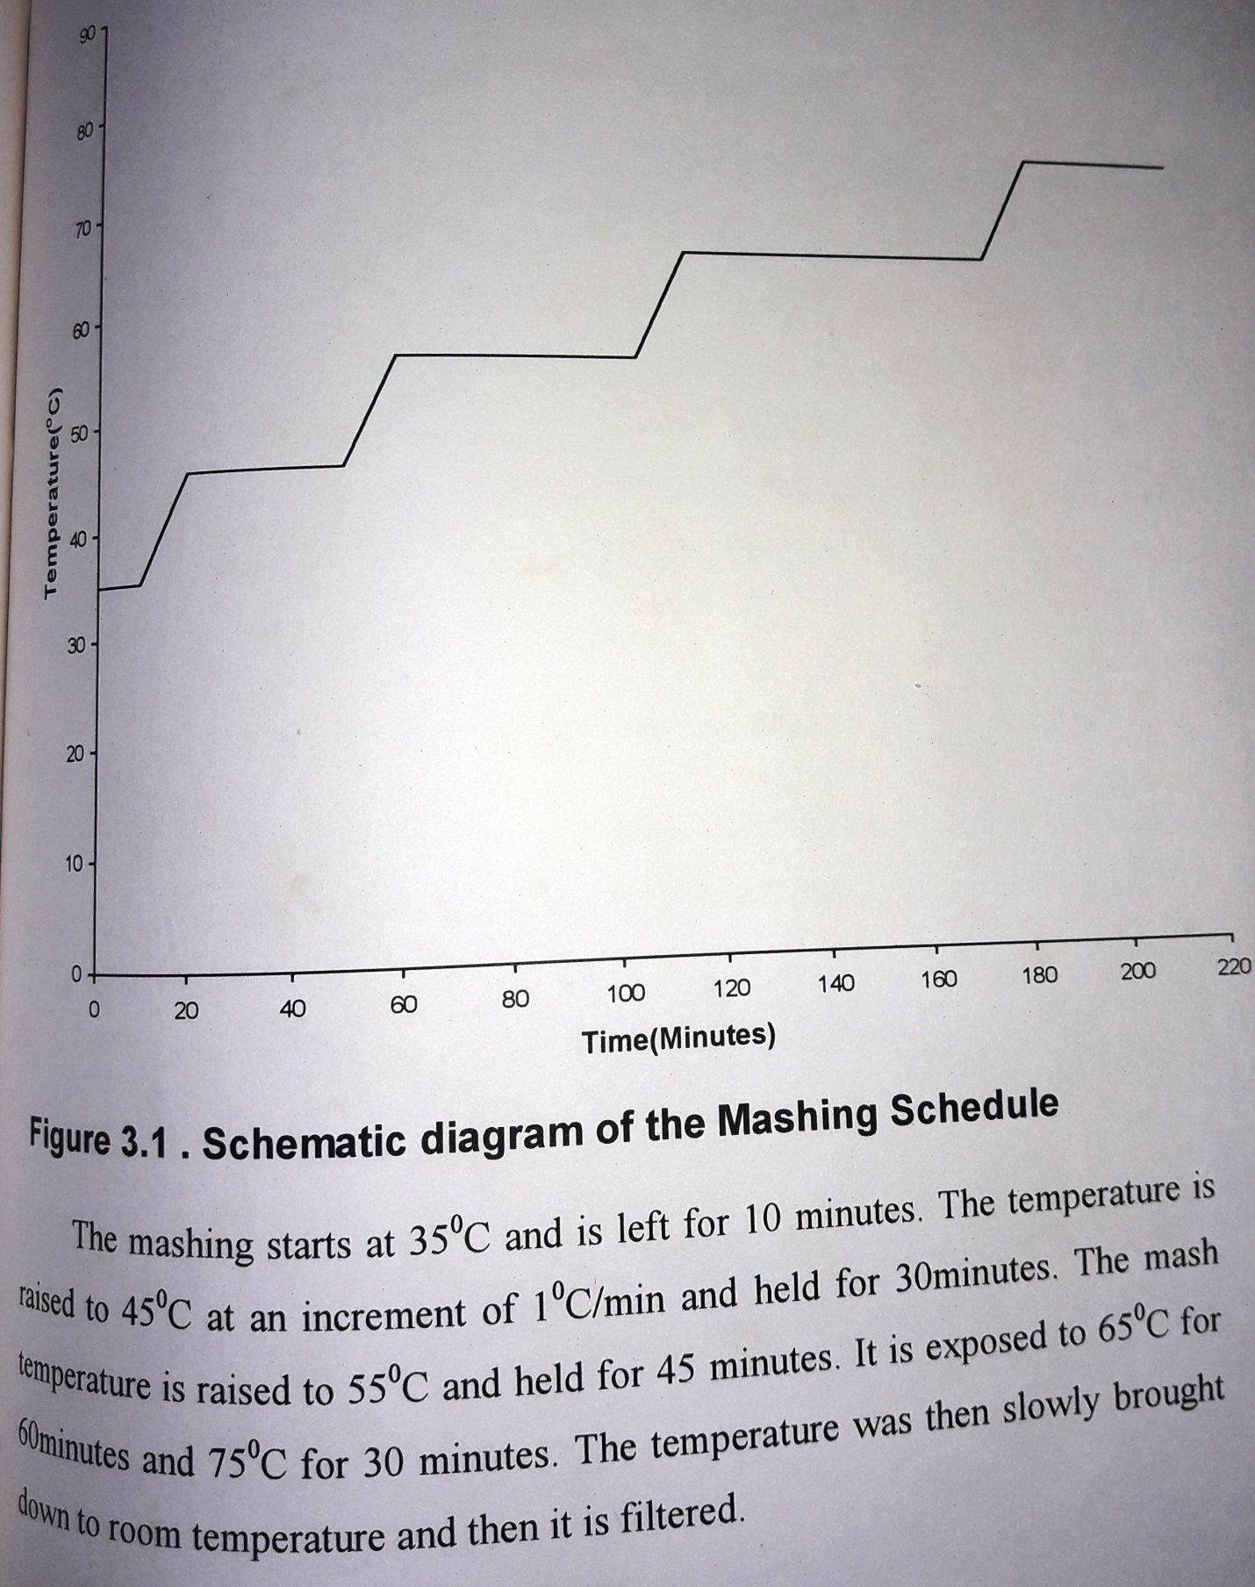

3.8 Microorganism
Yeast strain Saccharomyces cerevisiae (NCIM 3288), obtained from National Collection of Industrial Micro-organisms, National Chemical Laboratories, Pune, Indi, has been used in all the experiments.
3.8.1 Morphological aspects
The vegetative cells were singular and round to spheroidal in shape. Vegetative reproduction was by multi-lateral budding, No pseudo or true mycelium formation was observed. It was an ascosporogenous yeast, which forms one to four ascospores in each ascus.
3.8.2 Yeast maintenance
The culture was maintained on Malt-Yeast-Glucose-Peptone (MYGP) (Wickerham, 1951) agar slants and stored at 4ºC and was subcultured every 30 days.
3.8.3 The maintenance medium: The medium consists of,
Malt extract 0.3%
Yeast extract 0.3%
Peptone 0.5%
D-glucose 1.0%
Agar 2.0%
3.8.4 Inoculum preparation
To the 48h slant, 5 ml of sterile distilled water was added. The slant is shaken slowly to bring all the cells into solution. If necessary a sterile loop may be used to scrap the cells. The cell suspension is transferred into a centrifuge tube and centrifuged at 6000rpm for 10 minutes. The supernatant was discarded and the pellet was resuspended in 2ml of sterile distilled water and used as inoculums for the wort.

3.9 Fermentation
The wort is used for fermentation of ethanol by the submerged fermentation process.
3.9.1 Optimization of the parameters for sub-merged fermentation technique
In the present study, to standardize the physic-chemical and nutritional parameters, the following procedure was followed.

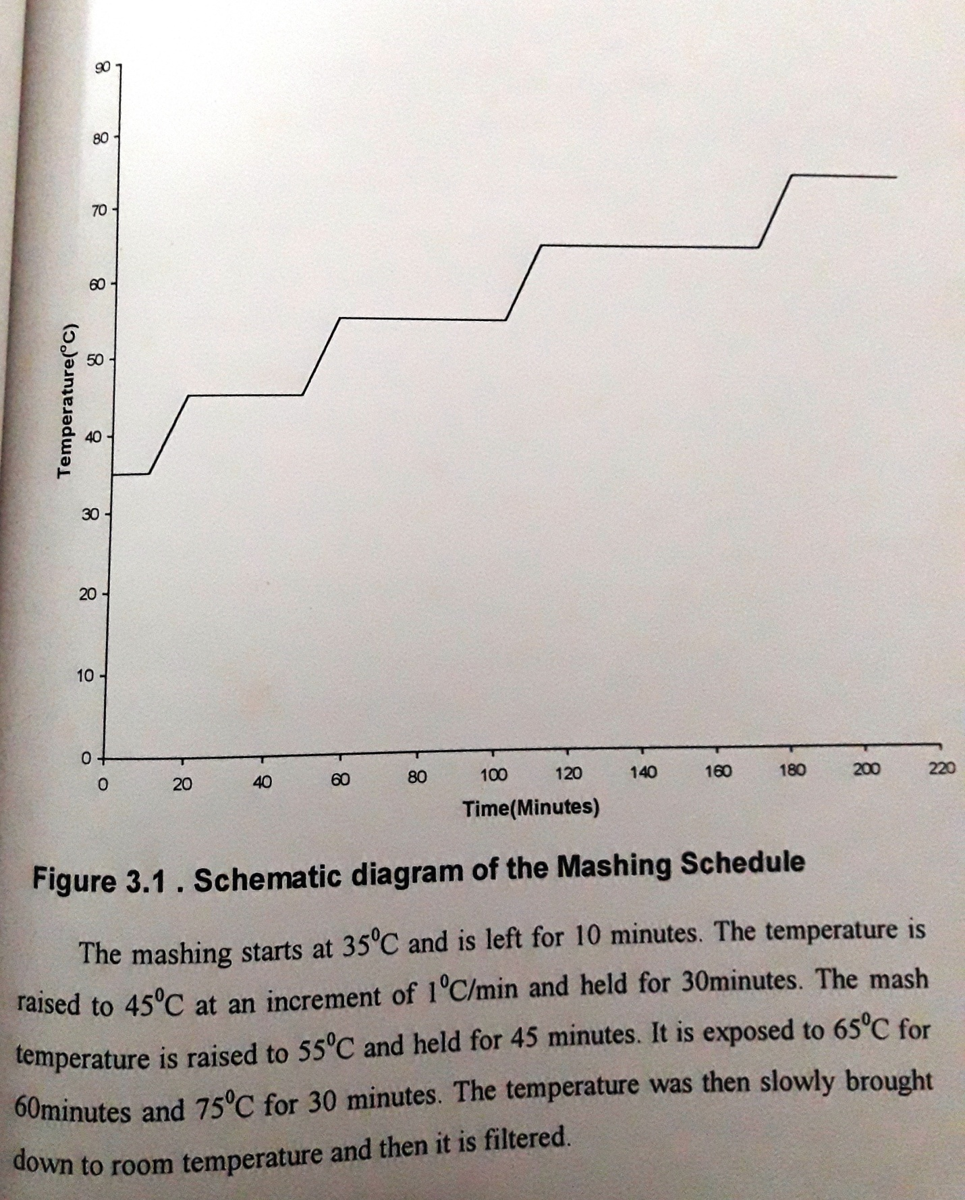

50ml of the filtered wort was taken in a 250ml Erlenmeyer flask. The pH of the medium was adjusted to 5.0 using 1N HCl and 5N KOH. The medium was autoclaved at 15lb pressure for 15 minutes and cooled. It was then inoculated with a single slat of the 2nd day old culture suspended in 2ml sterile distilled water. The flask was then placed on a Remi incubator rotary shaker at 30ºC at 150rpm. The samples were collected at every 12hours interval to estimate ethanol yield, total sugars and cell number.
3.9.2 Standardization of physical parameters
The physical parameters, which effect fermentation efficiency by Saccharomyces cerevisiae, were optimized. The optimal value of the previous parameter was incorporated in the medium before studying the next parameter. The following optimization studies were carried out.
3.9.2.1 Effect of substrate concentration
The total sugar concentration was varied between 4.4 and 22% (w/v) to study the effect of dilution of wort on ethanol production. The pH of the medium was adjusted to 5.0 and the flask was incubated at 30ºC temperature and 150rpm after inoculating sterilization medium.
3.9.2.2 Effect of pH
The pH range was varied between 3.0 to 8.0, and the flasks were incubated at 30ºC and 150 rpm for the present study.
3.9.2.3 Effect of temperature
The incubation temperature was varied between 10ºC and 40ºC, and the flasks wre kept at 150rpm.
3.9.2.4 Effect of agitation
The effect of agitation was observed by varying the rpm between 50 to 250 rpm.
3.9.2.5 Effect of inoculums level
The inoculums level was varied by varying the initial cell concentration in the range from 1.2 x 10⁶ to 8.4 x 10⁶.
3.9.3 Standardization of chemical parameters
After the optimization of the physical parameters, keeping the optimal physical parameters constant, the chemical parameters were varied. During this process the optimum value of the first was incorporated while optimizing the next parameters.
3.9.3.1 Effect of different nitrogenous sources
To the filtered wort, different concentrations of nitrogenous sources were added by varying their concentrations between 0.5 and 3.0 g/l for urea and peptone and a concentration range of 0.25 g/l for (NH₄)₂SO₄ were used for the study. Every time the pH was adjusted after adding the nutrients and before autoclaving the medium. The temperature and rpm were maintained at their optimal values after inoculation with the optimal inoculums level.
3.9.3.2. Effect of yeast extract and malt extract
The yeast extract and the malt extract provide nitrogen along with vitamins and other nutrients required for the growth of the yeast and ethanol production. To the selected nitrogen added to the wort, the malt extract and yeast extract were added to study their effect individually. Their concentrations were varied between 1 and 8 g/l.
3.9.3.3 Effect of phosphate ions
In this investigation, the effect of KH₂PO₄, K₂HPO₄, NaH₂PO₄ and Na₂HPO₄ were studied. Their concentrations were varied between 1 to 6 g/l.
3.9.3.4 Effect of trace metals
Different concentrations of trace metals were used to study the effect of their supplementation in the wort for ethanol production. Seven different metal ions were selected for the study. The metal salts used along with their concentrations (mg/l) are,
CuSO₄ | - | 1 to 5
FeSO₄ | - | 0.5 to 3.0
MgSO₄ | - | 0.5 to 3.0
MnSO₄ | - | 0.5 to 3.0
ZnSO₄ | - | 0.5 to 3.0
CoCO₃ | - | 0.5 to 3.0
CdSO₄ | - | 0.25 to 1.25

3.9.3.5 Effect of chelating agents
The effect of chelating agents was carried out before the optimization of the fermentation parameters and also after their optimization. This was done to check the effect of the salts added during mashing and to verify if the salt supplements added during the fermentation would show any toxic effect on the organism.
The metal chelators used in the study are Ethylene Diamine Trichloro acetic acid (EDTA), Sodium potassium tartarate (SPT) and Potassium ferrocyanide concentrations were varied between 1.0 and 5.0 mg/l, whereas SPT concentration was varied between 1.0 and 10.0mg/l.
3.10 Bioreactor studies
The production of ethanol was carried out using a 2.0 L, mechanically agitated stirred tank bioreactor (Biostat – M). The batch fermentation was carried out using 1.0L of the optimized medium as the working volume. The Sachharomyces cerevisiae does not need any aeration but requires agitation. Hence the effect of agitation was studied.
3.11 Fed batch studies
Sequential fed batch studies were carried out. The working volume selected was 1.05 liters. The nutrients were fed at specific intervals of time to the optimized medium at stationary phase.
3.11.1 Optimization of the feed intervals
The effect of addition of the feed at different time intervals was studied by adding the medium at 3rd, 4th and 5th h after the fermentation has reached stationary phase.
3.11.2.1 Effect of high inoculums levels
The effect of addition of high cell concentration, i.e., the cell concentration observed at the stationary phase to the medium and addition of feed at 3h time interval until, it reaches the maximum working volume was observed.

3.12 Evaluation of growth kinetics
Growth kinetics for batch culture fermentation using Saccharomyces cerevisiae were evaluated by Monod equation.
After inoculation there is a period during which no growth appears to take place, this period is referred to as the log phase and may be considered as a time of adaption. In a commercial process, the length of the lag phase should be reduced as much as possible and this may be achieved using a suitable inoculums. Following a period which the growth rate of cells gradually increases, the cells grow at a constant, maximum rate and this period is known as a log or exponential phase. The exponential phase may be described by the equation 1.1
dx/dt = μx ----------------------------- 1.1
Where, x is the concentration of microbial biomass,
t is time in hours and
μ is the specific growth rate in hours ⁻¹
On integration equation (1.1) gives:
X_{t} = x₀ e^{μt} ------------------- 1.2
Where, x₀ is the original biomass concentration
Where , x₀ is the original biomass concentration
x_{t} is the biomass concentration after the time interval t hours
e is the base of the natural logarithm

On taking natural logarithm, equation 1.2 becomes,
ln x_{t} = ln x₀ + μt ------------------- 1.3
Thus, a plot of the natural logarithm of biomass concentration against time should yield a straight line. The slope of which should equal ‘μ’. During exponential phase, the organism is growing at its maximum specific growth rate μ_{max}, for the prevailing conditions.
Growing the organism in the presence of a range of substrate concentrations may expose the nature of the limitation of growth, as increase in substrate concentration gives a proportional increase in total biomass at stationary phase, which may be explained by the equation 1.4.
x = Y (S_{R} – s) ------------------------ 1.4
Where, x = concentration of biomass produced
Y = yield factor
S_{R} = Original substrate concentration
S = residual substrate concentration

The decrease in growth rate and the cessation of growth due to the depletion of substrate may be described by relation between μ and the residual growth limiting substrate, represented in equation 1.5 ( Monod , 1942).

μ = μ_{max} S ------------------- 1.5
K_{s} + S
K_{s} = substrate utilization constant numerically equal to substrate concentration, when μ is half μ_{max} and is a measure of the affinity of the organism.
SECTION B
3.13 Estimation methods
3.13.1 Determination of moisture content
Moisture content of the sample was determined by the direct oven method of Association of Official Agricultural Chemists (AOAC, 1960).
One gram of the desprouted cotyledons were taken in a porcelain crucible and kept in an electric oven at 110ºC for about 4 – 5 hours (until constant weight), cooled in a dessicator and weighed. From the loss in the weight of the sample, moisture content was determined.
% Moisture content (w/w) = Loss in weight x 100
Total weight

3.13.2 Determination of total sugars
The total sugars in the malt were estimated by Anthrone method (Jose Tarquinio Prisco et al., 1981).
Anthrone Reagent: 0.1 gm of anthrone was dissolved in 50 ml of 96% sulfuric acid
Standard glucose solution: A glucose standard solution was prepared by dissolving 100mg glucose in 100ml distilled water (1mg/ml)
Procedure: To 4 ml of anthrone reagent was added 2ml of the centrifuged malt extract (diluted as per the requirement) and kept in a boiling water bath for 5 minutes. After cooling to room temperature, absorbance at 625nm was measured using a single beam spectrophotometer against a blank containing 2ml of 80% ethanol and 4ml anthrone reagent.
Standard graph: a series of test tubes containing glucose concentration were prepared in a range of 0.01 to 0.1% (w/v), by diluting the standard solutions. To each tube, 4ml anthrone was added and the same procedure was followed.

3.13.3 Amylases extraction from the seeds
5g of cotyledons were ground into a fine paste in a mortar with 0.025 M cold acetate buffer, containing 2.6mM CaCl₂, pH 5.6. The paste was suspended in the buffer and made upto 100ml using the same buffer. The resulted homogenate was centrifuged at 7000g for 15minutes and the supernatant was used for the estimation of amylases, sugars and protein.

3.13.4 Estimation of α- and β- amylases
The supernatant was divided into two parts of which one is used to estimate the total amylase activity and the other is heated for 15 minutes at 70ºC. This causes the denaturation of β- amylase. It is centrifuged and used for the estimation of α-amylase. The difference in the absorbance read for the reducing sugars formed as a result of the two parts gives the β- amylase activity (Jose Tarquinio Prisco et al., 1981 and Benedelow, 1963). The reducing sugars formed were estimated by DNA method.
Reagents: 1) 1% starch solution in 0.025M acetate buffer
2) DNA reagent
3) Enzyme extract (diluted before use)
Procedure: To 1ml of pre-incubated starch solution. 1ml of enzyme extract ( ~1: 1000 diluted) was added and incubated at 37ºC for 10 minutes. 2ml DNA reagent was added immediately and kept in a boiling water bath for 10 minutes. To the blank tube the DNA reagent was added at 0th minute to stop the reaction. The OD is read at 520nm.
The enzyme activity is expressed in terms of mg of maltose liberated per gram of malt.

3.13.5 Estimation of reducing sugars
The reducing sugars present in the malt as well as those formed as a result of amylase activity were determined by DNA method ( Kirsop, 1953).
Dinitro salicyclic acid reagent: 1gm of 3,5- Dinitro salicylic acid (DNA) was ground in 10ml distilled water. 1.6gm NaOH was solubilized in 50ml distilled water, which was added to the DNA paste and stirred till a clear solution is obtained. To this 30gm sodium potassium tartarate (Rochelle salt) was added and mixed well. When the solution attains the room temperature, it is made upto 100ml and filtered through a Whatman No.1 filter paper. The reagent was stored in a stoppered containers.
Standard maltose solution: A standard solution of maltose was prepared at a concentration of 1mg/ml (0.1% w/v).
Procedure: A series of test tubes were taken and to each tube standard maltose solution was added from 0.1ml to 2.0 ml. The volume in all the tubes was made upto 2ml. 2ml DNA reagent was added to all the tubes. A blank was prepared with 2ml distilled water instead of maltose solution.
Procedure for unknown sample: 2ml of diluted unknown sample and 2ml DNA reagent were added to test tube and treated as above. The resultant OD was compared with the standard graph to obtain the concentration of reducing sugars in mg/ml.

3.13.6 Estimation of protein
Oliver H. Lowry et al (1951) developed a spectrophotometric method for the measurement of protein. The protein in the malt is estimated by this method.
Reagent :
Reagent A- 2% sodium carbonate in 0.1N NaOH
Reagent B- 0.5% Copper sulphate solution in 1% sodium potassium tartarate solution
Reagent C- To 50ml of reagent A, 1ml of reagent B was added prior to use
Folin-Ciocalteau reagent- The reagent is commercially available and has to be diluted with equal volumes of distilled water before use.
Standard protein solution: A standard solution was prepared using Bovine serum albumin to get a protein concentration of 0.25mg/ml.
Procedure- Aliquots of protein solutions are pipette out to get a concentration range between 0.005mg and 0.25mg/ml in 4ml of working volume. Dilutions are made using distilled water. To each tube 5.5ml of reagent C was added and mixed well. It was allowed to stand for 15minutes. 0.5ml of Folin’s reagent was added to the test tubes, mixed rapidly and allowed to stand for 30 minutes in dark. The blue color formed was measured at 650nm and the blank was prepared with 4ml distilled water.
A standard graph was plotted with protein concentration on X-axis (mg/ml) and OD on Y-axis. The unknown sample is taken, the solution is made upto 4ml and the procedure similar to the standard solutions was followed. The OD is compared with the standard graph and concentration was noted.

3.13.7 Estimation of proteolytic enzymes
One gram of cotyledons were ground in a motor with cold 0.02M Na-K Phosphate buffer, pH 7.6. The homogenate was centrifuged at 8000x g for 20minutes and the supernatant was used for the assay ( Eneas Gomes Filho and Jose Tarquinio Prisco, 1978).
The proteolytic activity was determined as the capacity to hydrolyze casein. The casein left unhydrolyzed was estimated by precipitating it using 10% TCA and redissolving in 1N NaOH and then estimated by Folin’s method. 1% casein in 0.02 M Na-K phosphate buffer was used as the substrate for proteases. The proteolytic activity was expressed as mg of casein hydrolyzed per hour. Specific activity was expressed as mg of casein hydrolyzed per hour per mg of protein.

3.13.8 Estimation of starch content
The starch content of the flour was estimated by first defatting the malt flour using 65% ethanol. The suspension is filtered and the insoluble starch is washed with distilled water and then finally collected into a known amount of acetate buffer. The suspension is centrifuged and the supernatant was discarded. The pellet is used for the estimated of starch content by the enzyme digestion method of Chiang and Johnson (1977).
To the starch 15mlof 0.05M acetate buffer (pH 4.8) containing 10mg of glucoamylase (Rhizopus) was added. The mixture was incubated at 55ºC for 16h for starch hydrolysis. The contents were diluted to 100ml with water and filtered. Reducing sugar content of the filtrate and that of the control were estimated by the method of Kirsop (1953).
% starch = 9.1 x reducing sugars (mg/ml)

3.13.9 Estimation of ethanol
Ethanol was estimated by the dichromate oxidation method of the neutral steam distillate (Dawes et al., 166; Neish, 1952). The concentration of reagents was modified as per convenience.
Reagents: 1) 0.5N K₂Cr₂O₇ in 5N H₂SO₄
2) 10% KI solution
3) 0.5N Na₂S₂O₃ solution
4) 0.5% starch solution
Procedure: 5ml of the fermented broth was centrifuged and 2.5ml of it was distilled into 10ml dichromate solution in a stoppered 50ml flask. This was kept in a boiling water bath attached with a condenser to ensure no loss of ethanol due to volatilization for 10 minutes. Cold water is circulated in the condenser and the contents of the flask are heated to ensure complete oxidation of dichromate by ethanol. The left over dichromate was estimated by the Iodometric method.
1ml of 10% KI solution was added and the flask was covered with a lid. The reaction was allowed for 5 minutes with occasional stirring for the complete liberation of iodine vapours. The condensed vapours on the walls and on the stopper were washed into the flask carefully. The iodine was titrated with thiosulphate solution until the brown color changes to straw green. The starch indicator was added which combines with the left over iodine to form a deep blue complex. Titration was continued until all the color disappears.
Volume of hypo consumed for blank (B) and that consumed for test (T) were noted down.
Calculation: Ethanol concentration (%): B-T x 0.5 x 46
B 2.5
Ethanol yield was expressed as the grams of ethanol produced per gram of glucose.
Y p/s = gm of ethanol
gm. of substrate
Specific ethanol productivity : Grams of ethanol produced per gram of substrate per hour.
qp = gm/gm-h

3.13.10 Determination of cell concentration
The cell number was determined by the serial dilution method. The changes in cell number were observed throughout the optimization studies and the fed batch studies. The growth rate was calculated.

3.13.11 Paper chromotography
To observe formation of higher saccharides and their disappearance during mashing with simultaneous increase in glucose and maltose by multiple ascending chromatographic technique ( Yu-Yen Linko et al , 1975).
Reagents:
- A solution of Butanol – Pyridine – water in the ration 6:4:3 was used for the ascending chromatography
- Saturated AgNO₃ in acetone
- 0.4% NaOH in methanol
- 0.25N Na₂S₂O₃ solution or Kodak F-24 can be used as fixing solution
- Whatman No.1 paper
Procedure- The samples were spotted on the Whatman No.1 chromatography paper of 25 x 20 cm dimensions. A pencil line is drawn to mark the spots for the samples at 2cm from the bottom side. The spots were marked at a distance of 1.5cm from the sides and the same distance was left between spots. The standard samples were spotted first and then the samples to be analyzed. The paper was air dried and all the samples were respotted 2 to 3 times.
The solvent was poured into the chromatographic chamber and left for 2h to saturate the chamber with the solvent vapours. The solvent level was maintained below 2 cm. the spotted paper was carefully placed in the solvent saturated chamber and left for ascending for 2h. The paper was withdrawn and sir dried till it becomes dry. It is again placed for ascending for 2h. The process is repeated 4 to 5 times and then finally air-dried for development.
Chromatography development: The paper was first dipped in saturated AgNO₃ solution. It was then dried and again dipped in 0.4% NaOH in methanol, dried and finally fixed with hypo solution.
The known samples and the unknown samples also migrate. By comparing the migration of different components of unknown to the known, the sugars are identified. The changes in the color intensity of the samples drawn at different time intervals indicate the formation of sugars during mashing.

